CUSTOMER JOURNEY MAP

|  |  |
| --- | --- |
| DATE | 21 JUNE 2025 |
| TEAM ID | LTVIP2025TMID52211 |
| PROJECT NAME | COSMETIC INSIGHTS : NAVIGATION COSMETIC TRENDS AND CUSTOMER INSIGHTS TABLEAU |
| MARKS | 4 MARKS |

**Technical Architecture Overview**

This solution processes cosmetic product data, performs trend and sentiment analysis, and delivers insights via interactive Tableau dashboards. The architecture includes data ingestion, transformation, visualization, and user interaction layers, deployed using scalable cloud technologies.

**Table-1: Components & Technologies**

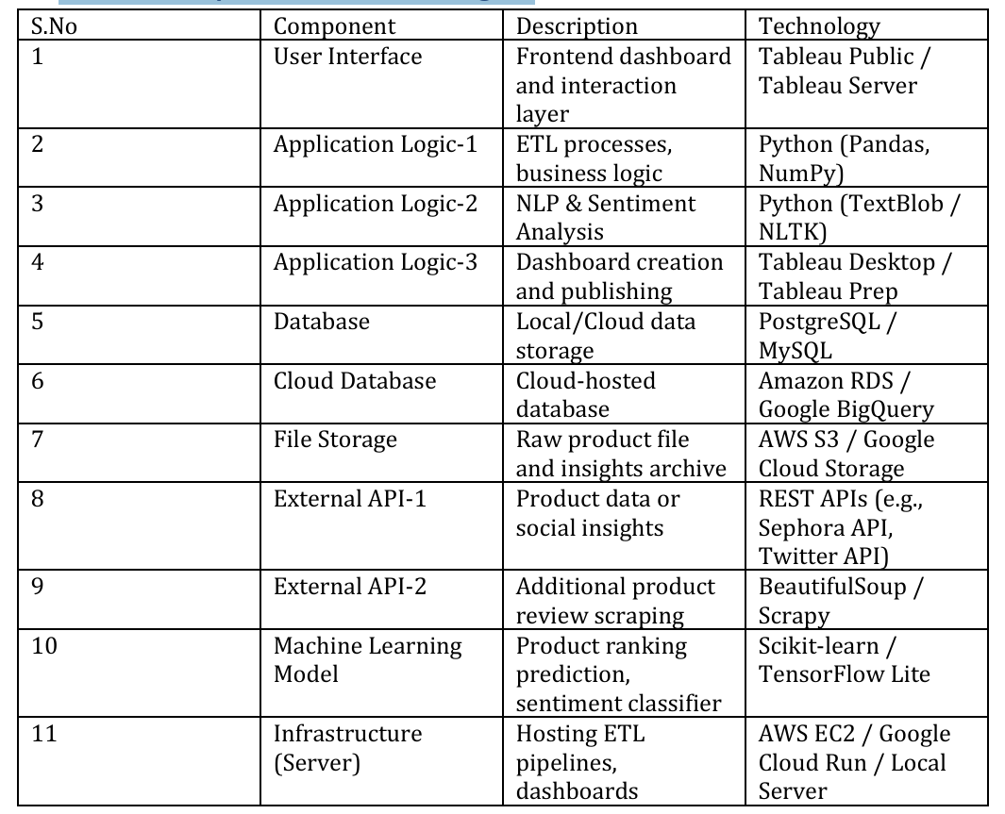

**Cosmetic Insights – Technology Stack**

**Table-2: Application Characteristics**

